**Microprocessor and Computer Architecture**

**UE20CS252**

**4th Semester, Academic Year 2021-22**

Date:

|  |  |  |
| --- | --- | --- |
| Name:  Vishwa Mehul Mehta | SRN:  PES2UG20CS389 | Section:  F |

Week#____4_______ Program Number: ____1___

Title of the Program

**Write a program in ARM7TDMI-ISA to find GCD of two numbers.**

**a. Assume operands to be in the CPU registers**

1. **ARM Assembly Code(1)**

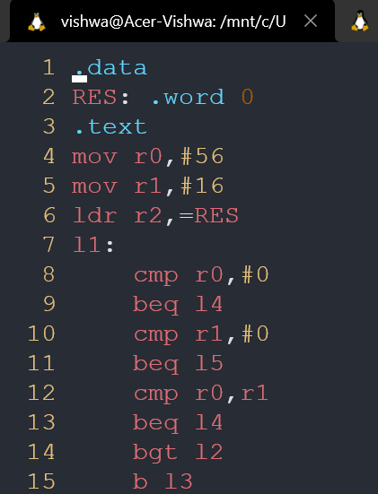 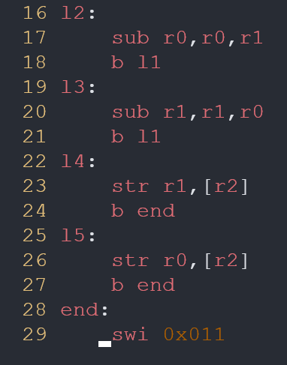

1. **Output Screen Shot (1)**

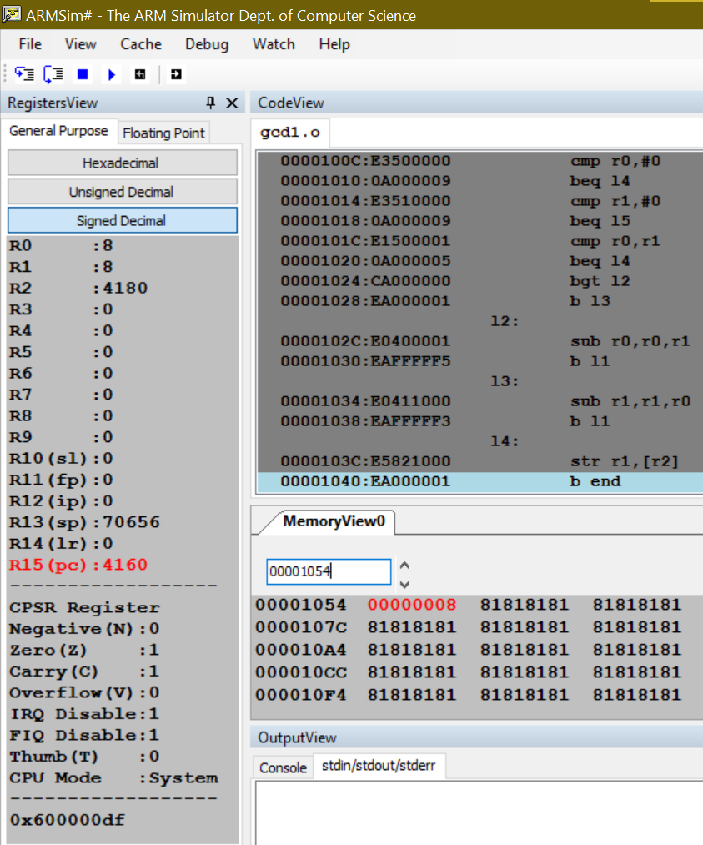

**b. Assume operands in the memory locations.**

1. **ARM Assembly Code(1)**

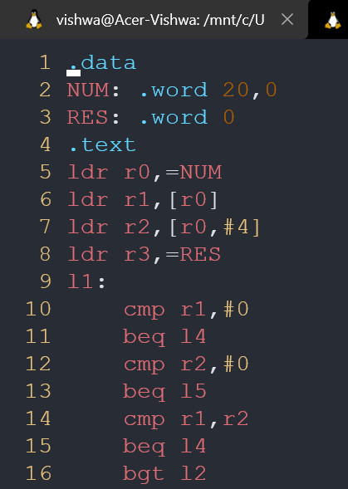 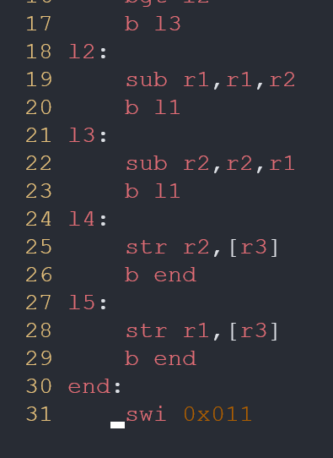

1. **Output Screen Shot (1)**

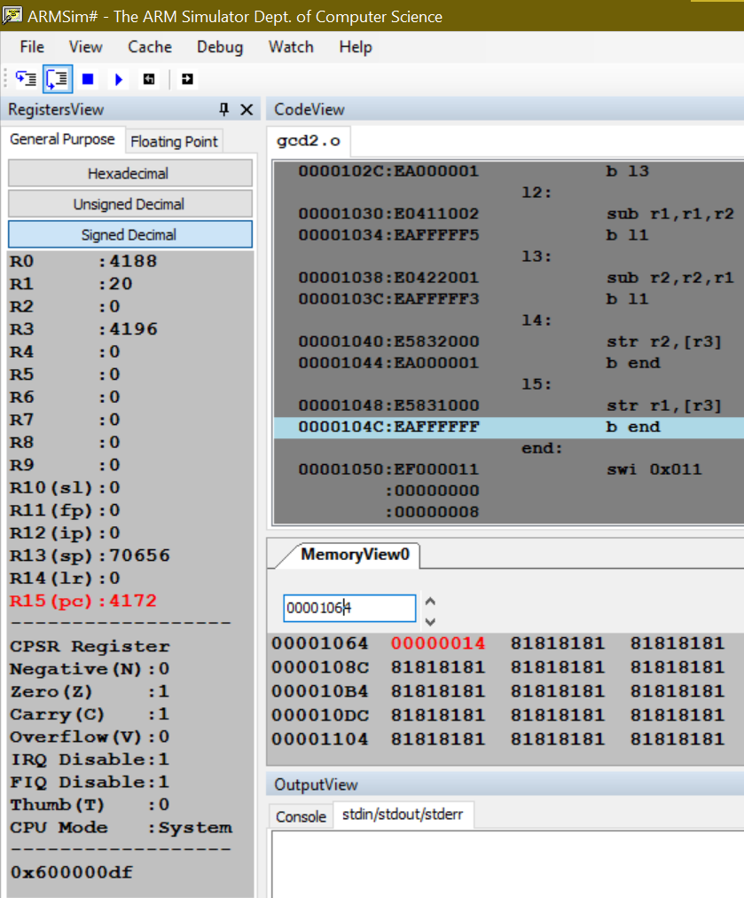

**Microprocessor and Computer Architecture**

**UE20CS252**

**4th Semester, Academic Year 2021-22**

Date:

|  |  |  |
| --- | --- | --- |
| Name:  Vishwa Mehul Mehta | SRN:  PES2UG20CS389 | Section:  F |

Week#____4_______ Program Number: ____2___

Title of the Program

**Write a program in ARM7TDMI-ISA to find the sum of N data items at alternate [ odd or even positions] locations in the memory. Store the result in the memory location.**

**a. Use Pre-indexing addressing mode**

**Odd:**

1. **ARM Assembly Code(1)**

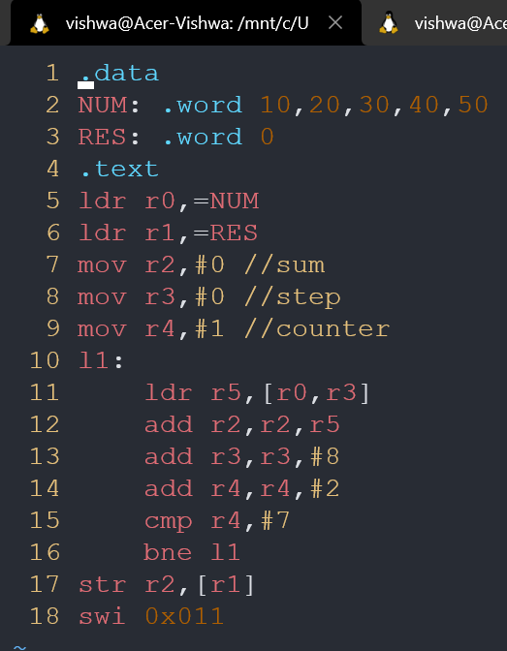

1. **Output Screen Shot (1)**

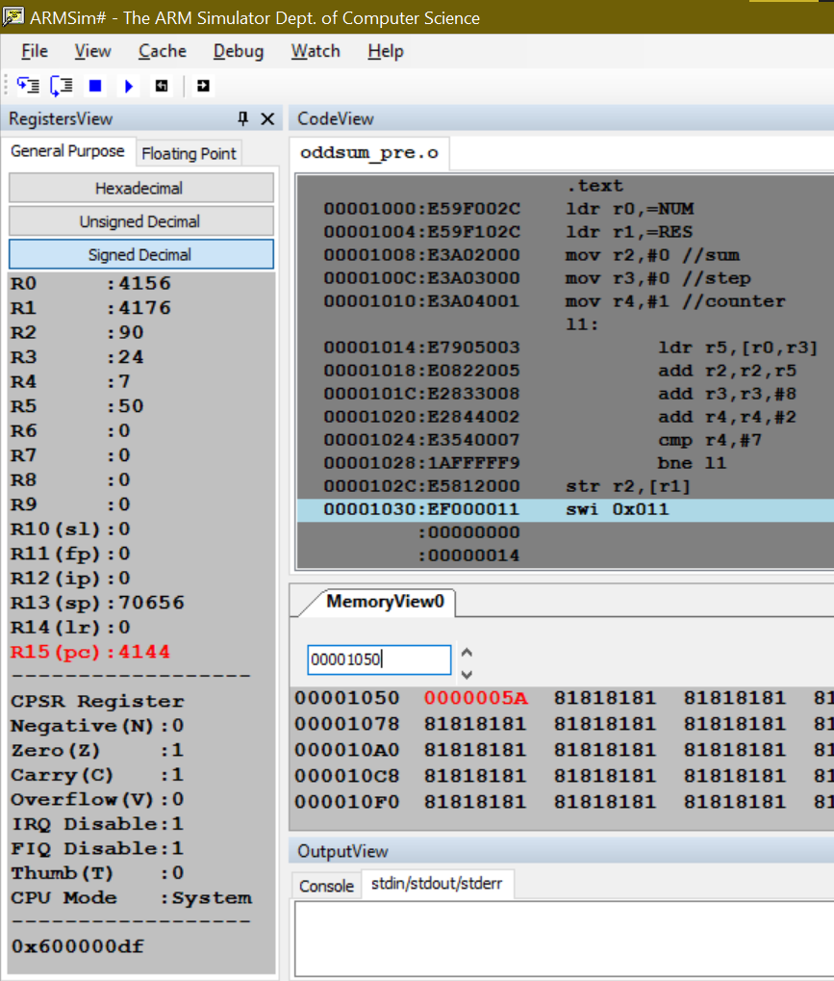

**Even:**

1. **ARM Assembly Code(1)**

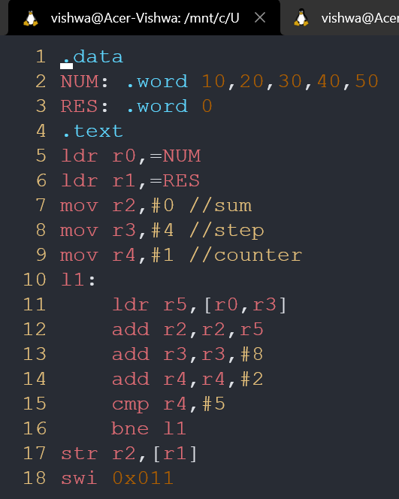

1. **Output Screen Shot (1)**

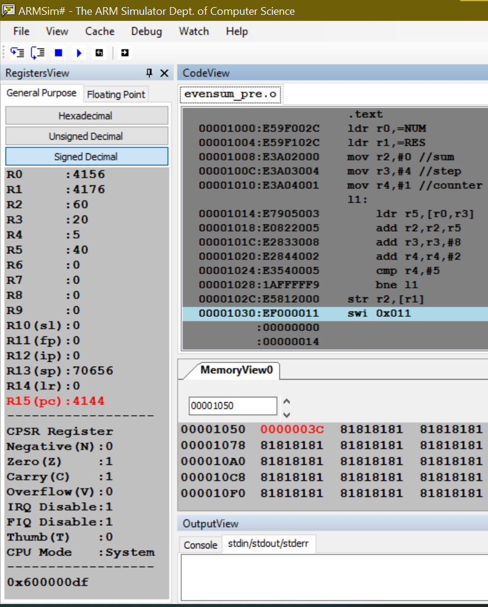

**b. Use Post- Indexing addressing mode**

**Odd:**

1. **ARM Assembly Code(1)**

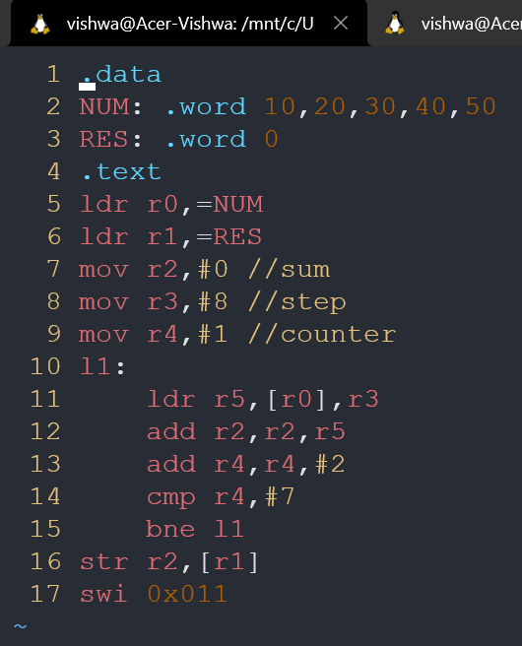

1. **Output Screen Shot (1)**

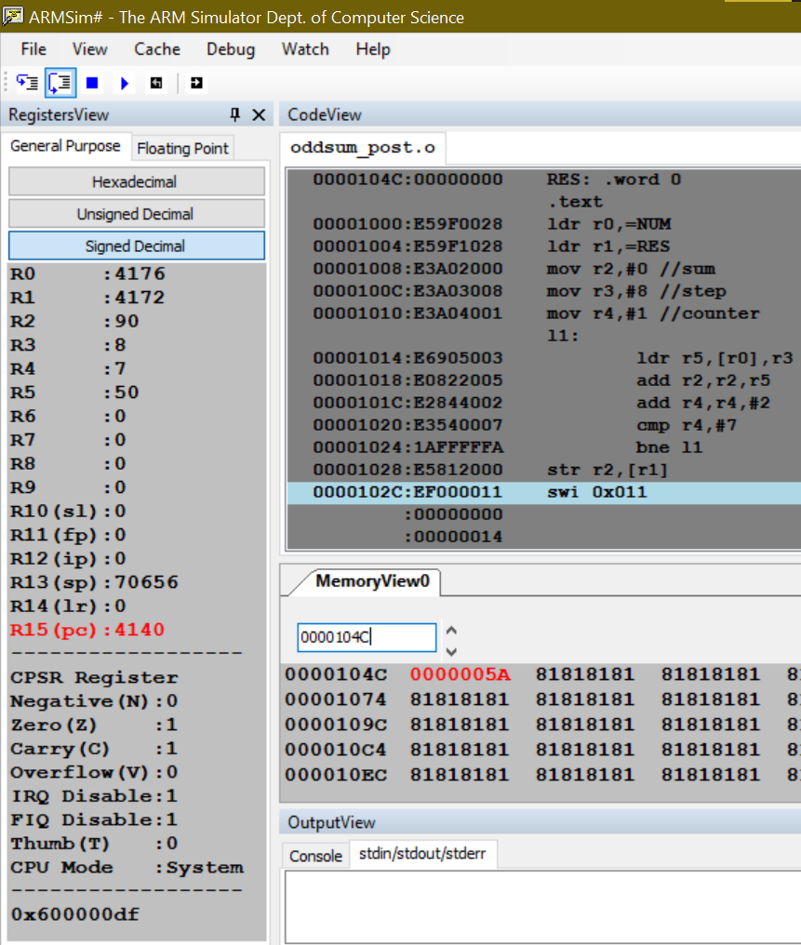

**Even:**

1. **ARM Assembly Code(1)**

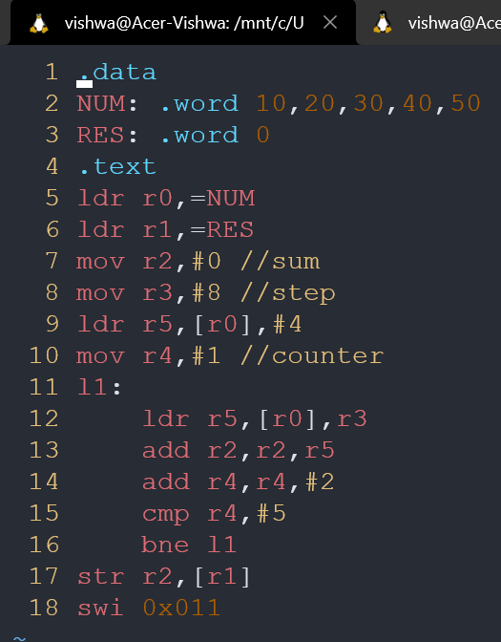

1. **Output Screen Shot (1)**

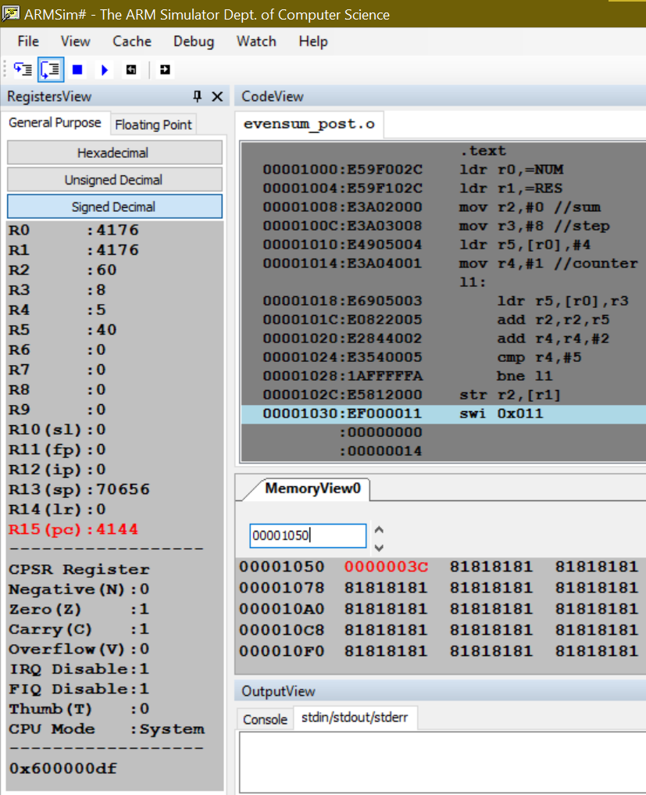

**Disclaimer:**

* The programs and output submitted is duly written, verified and executed by me.
* I have not copied from any of my peers nor from the external resource such as internet.
* If found plagiarized, I will abide with the disciplinary action of the University.

Signature: Vishwa Mehul Mehta

Name: Vishwa Mehul Mehta

SRN: PES2UG20CS389

Section: F

Date: 07/02/2022